FOR IMMEDIATE RELEASE

VI resident appointed as the new civilian aide to the secretary of the Army

ST. CROIX, Virgin Islands – Former Virgin Islands National Guard member, Beresford F. Edwards, was appointed as the new Civilian Aide to the Secretary of the Army during an investiture ceremony at the Pentagon in Washington D.C., Nov. 13, 2019.
The Honorable Ryan D. McCarthy, Secretary of the Army, selected Edwards to represent the Virgin Islands.
"It is my distinct privilege to welcome Beresford to the CASA program," McCarthy said." Our CASAs offer fresh eyes and bring new perspective to how we recruit future Soldiers.
A distinguished graduate of the Virgin Islands Military Academy, Lt. Col. (retired) Beresford Edwards served over 32 years in the Virgin Islands National Guard as a military police officer. Since his retirement, he has served as the Chair Emeritus of the Virgin Islands Committee for the Employer Support of the Guard and Reserve (ESGR), bridging the gap between local employers and the VING. He also serves as the president of the Virgin Islands National Guard Association (VINGA).
"First, I thank God for His unmerited favor. I would also like to thank Brig. Gen. (VI) Kodjo Knox-Limbacker for nominating me for the CASA position, and I am grateful to Secretary McCarthy for selecting me to serve in this prestigious position," Edwards said. "Since retiring from military service in 2012, I dedicated my life to serve the men and women of the Virgin Islands National Guard. I look forward to the opportunity to serve the Guardians of the Eastern Front in my new capacity."
CASAs serve a two-year term without compensation and may extend to a total of 10 years of service. They are a vital part of the Army, promoting good relations between the Army and the public and advising the Secretary about regional issues. Each state, along with the District of Columbia and the five U.S. territories have one or more CASAs appointed to provide a vital link between the Army and their local communities.
“Mr. Edwards’ appointment is a testament to our homegrown talent,” said Knox-Limbacker. “As the CASA, he will be the Army’s link to the people. He will continue to put service before self during a pivotal time in the history of the Virgin Islands National Guard. I am confident his efforts will enable VING to continue to be ready, relevant, and a responsive joint warfighting force.”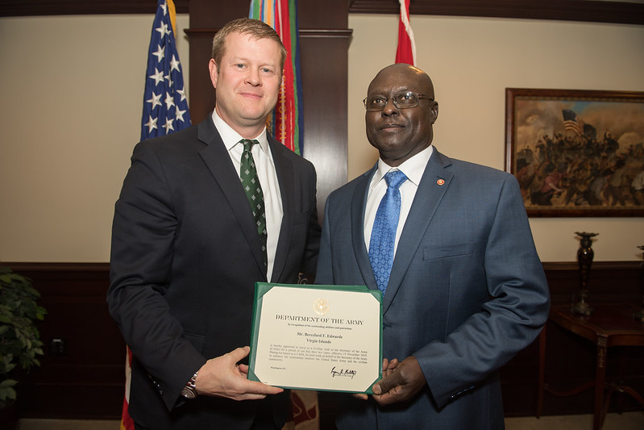
The Honorable Ryan D. McCarthy, left, Secretary of the Army, congratulates Beresford F. Edwards on appointment as CASA, Virgin Islands. (U.S. Army photo by Sgt. Dana Clarke)

