A PUBLICATION OF THE VIRGIN ISLANDS PORT AUTHORITY
Volume 11 Issue 1 www.viport.com 2015 Spring/Summer Edition

VIPA Received Governor & Senate Approval of Two Permits to Improve St. Croix’s Seaport Infrastructure

VIPA has received approval from Governor Kenneth E. Mapp and unanimous approval by the 31st Legislature for two permits that will help the Port Authority improve the marine port infrastructure on St. Croix.

CZM Permit No. CZT-2-15 (W) to dr edge the Schooner Bay Channel in the Christiansted Harbor will permit VIPA to dredge approximately 38,800 cubic yards of material from within the existing channel. CZM Permit No. CZX-31-14 (L&W) for shor eline r epair s at the Svend Ovesen Seaplane Terminal allows VIPA to repair the existing concrete apron, construct a new sheet pile wall, and remove 20 cubic yards of contaminated soil at and seaward of Plot No. 10 Water Gut Reclaimed Land, Christiansted, St. Croix.

Allowing the Port Authority to dredge Schooner Bay will provide safe entry for small cruise ships at the Gallows Bay Dock and enable plans to move towards the separation of cargo and passenger operations in Gallows Bay.

The apron at St. Croix’s only seaplane facility is literally falling into the sea, said VIPA Executive Director, Carlton Dowe. The project will create a safe and attractive dock for travelers and users of the Ovesen Seaplane Terminal, as well as prevent oil-contaminated dirt from running into the sea and destroying a precious natural resource, he said.

Both permits are now pending approval by the US Army Corp of Engineers (USACE). Dowe said that VIPA is prepared to put both projects out to bid when the Authority receives the approval from the USACE and work will begin immediately.

The $1 million Schooner Bay Dredging project will be funded by a
$500,000 contribution from the USVI Government via the Community Facilities Trust Account. VIPA will use $500,000 in bond proceeds
acquired in 2014 to fund the remainder of the project. The repairs to the
Ovesen Seaplane Facility are estimated to cost $1.5 million and will be
funded by VIPA through its capital improvements budget.

Svend Ovesen Seaplane Terminal, Christiansted

Gallows Bay Dock, Christiansted
From the Board Room……………….….…….2 CEKA Third Exit Lane Opens….….….………3 VIPA STX Projects/Future Development 4-5
Crown Bay Cruise Pier Feasibility…......…. 6
Employee News……………………...….…6—7 Community Outreach…………...…….……. 8

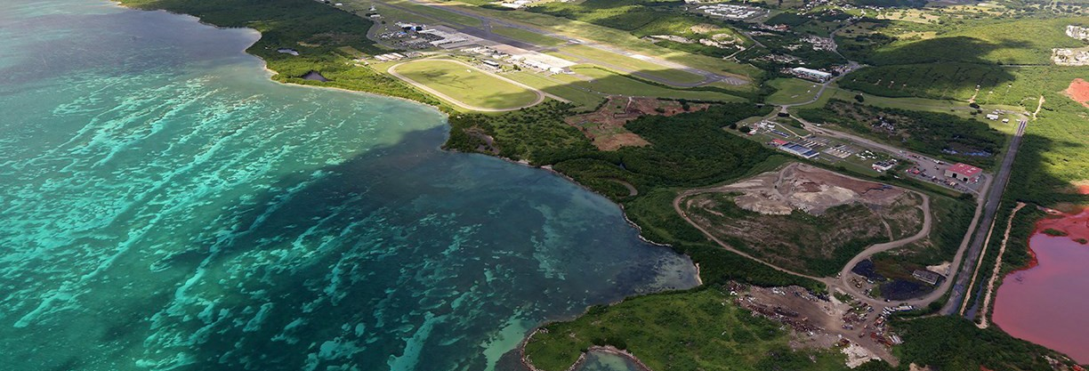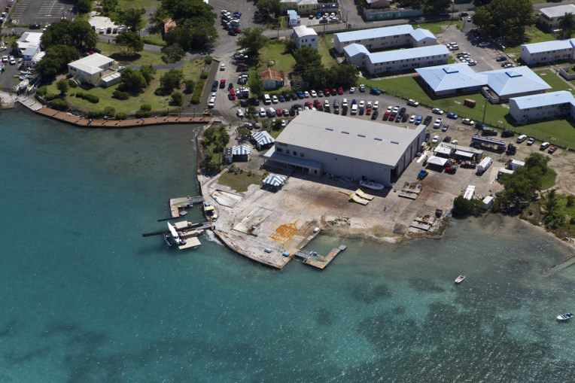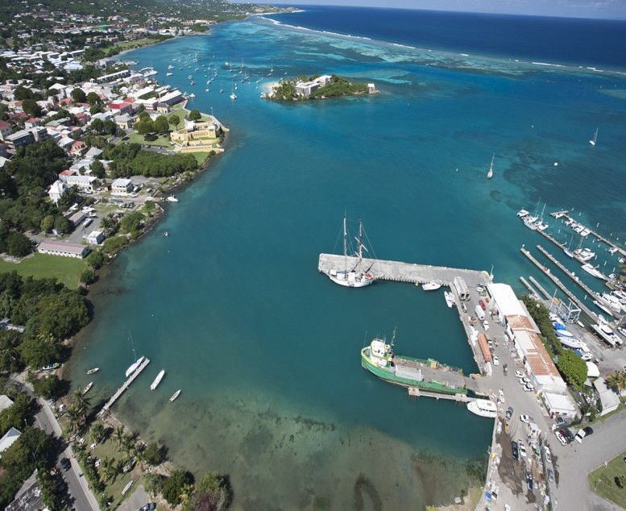————————————Facebook.com/usviports  Twitter.com/usviports————————————

THE VIPA PORTFOLIO IS PUBLISHED BY:
The Virgin Islands Port Authority
P.O. Box 301707
St. Thomas, VI 00803-1707
Tel: (340) 774-1629
Fax: (340) 774-0025

Roberto Cintron is VIPA Board Chairman

Roberto C. Cintron was elected as the Chairman of the Virgin Islands Port Authority Governing Board of Directors in January. He was appointed to a three-year term on the Port Authority Board in April 2014 as a private citizen representing St. Croix. Cintron is president of Jay-Ro-Mar, Inc. and a co-owner of New

Web site: www.viport.com
E-mail: info@viport.com

The Honorable Kenneth E. Mapp
Governor of the U.S. Virgin Islands

The Honorable Osbert E. Potter
Lt. Governor of the U.S. Virgin Islands

Roberto C. Cintron, P.E.
Chairperson of the Board Private Sector Member, St. Croix

The Honorable Beverly Nicholson Doty Vice Chairperson of the Board Commissioner Designee of Tourism

Mr. Allison Petrus
Secretary of the Board Private Sector Member, St. Thomas

The Honorable James Carroll, Esq.
Acting Attorney General

Mr. Manuel Gutierrez Jr.
Private Sector Member, St. Croix
Wave Development. He also provides private
engineering consulting, land development and survey services while serving as a board member on the Board of Land Use Appeals. Cintron previously served as the assistant commissioner of USVI Department of Public Works for more than five years. He holds a bachelor's degree in civil engineering from the University of Florida.

The board also elected USVI Tourism Commissioner Designee Beverly Nicholson-Doty as its Vice Chairperson, and Allison Petrus as its Secretary. Petrus, a successful entrepreneur and private citizen representing St. Thomas, was appointed to a three-year term in June 2012.

The board has also selected new committee members:
Roberto C. Cintron, PE
Board Chairman

Beverly Nicholson-Doty
Vice Chair

Allison Petrus
Secretary

The Honorable Gustav James
Commissioner Designee of Public Works

Mr. Jose E. Penn
Acting Chairman, Economic Development Authority Board

Dr. Yvonne E. L. Thraen
Private Sector Member, St. Thomas

Mr. Carlton Dowe
Executive Director

Mr. David W. Mapp
Assistant Executive Director

Finance Committee Allison Petrus - Chair Manuel Gutierrez Jr. Jose Penn

Property Committee Manuel Gutierrez Jr. -Chair Jose Penn
Allison Petrus

Personnel Committee Beverly Nicholson-Doty Roberto Cintron, P.E. Yvonne E. L. Thraen, PhD

Projects & Operations Roberto Cintron, P.E. - Chair Gustav James
Beverly Nicholson-Doty Yvonne E. L. Thraen, PhD
Marketing Committee Beverly Nicholson-Doty Roberto Cintron, P.E. Yvonne E. L. Thraen, PhD

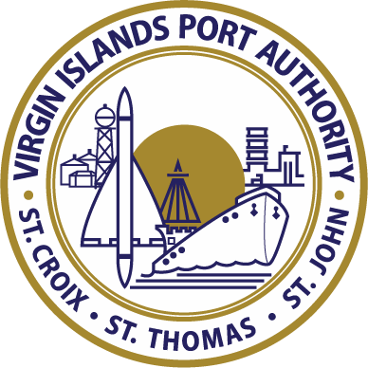

Page 2
Mrs. Monifa Marrero Brathwaite
Public Information Officer Editor & Layout

Assistant Editors
Ms. Julice Harley, Chief of Staff Ms. Damali Rogers, Special Assistant

Established on Feb. 11, 1969, the Virgin Islands Port Authority (VIPA) is a semi-autonomous agency that owns and manages the two airports and the majority of the public seaports in the United States Virgin Islands. We are also charged with controlling the harbors in the territory. VIPA is a critical arm of the USVI economy, and is committed to maintaining and developing the airports and seaports of the territory to accommodate the current and future demands of its users. The Port Authority is self
-supporting and receives no tax revenues from the U.S. Virgin Islands government.

Competitive Bidding Regulations Revised
On May 27, 2015, VIPA’s Board revised its policy regarding competitive bidding regulations to grant local companies alternatives, in lieu of a performance and payment bond in the full amount of the contract, when attempting to obtain a contract from VIPA where no federal funds are involved.

For contracts in excess of $1 million but less than $2 million, local contractors may post an Irrevocable Letter of Credit (IRC) from a lending institution licensed and regulated in the US Virgin Islands and the contract will be subject to withholding 10% to 25% of the contract price until satisfactory completion. For contracts less than
$1 million, local contractors can post either an IRC from a lending institution licensed and regulated in the US Virgin Islands or the contract will be subject to withholding from 5% to 15% of the contract price until satisfactory completion.
VIPA Portfolio Spring/Summer 2015

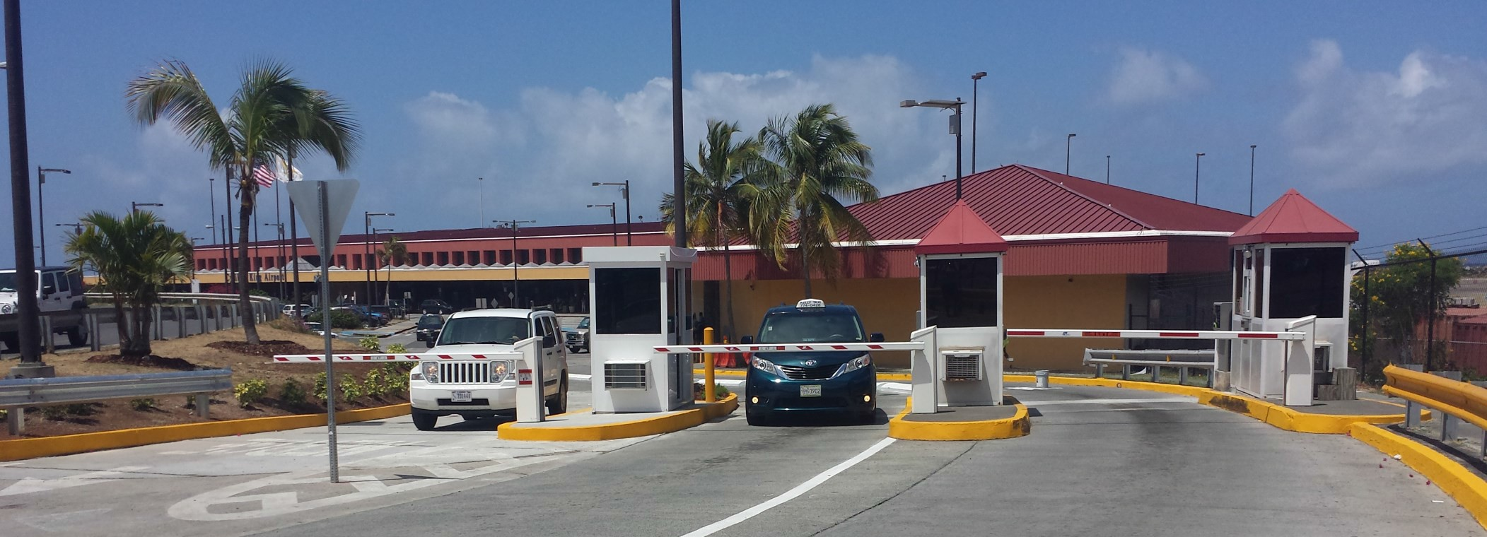Traffic Relief at CEKA: Third Exit Lane Opens

The Virgin Islands Port Authority has completed the construction of a third lane to exit the airport parking lot. The first lane on the far left is designated for the VI Taxi Association drivers who have an operations agreement at CEKA. It will alleviate some of the traffic congestion and improve the customer experience at our airport. In addition to the new exit lane, VIPA has placed all three parking lot attendant booths on generator power and landscaped the area.

East Gregerie Channel Crown Bay Dredging on Schedule

The US Army Corps of Engineers approved a permit on February 23 which allows VIPA to dredge the East Gregerie Channel and a section along the northern side to the Austin Monsanto Marine Terminal cruise pier in Crown Bay, St. Thomas. The dredging will provide safer berthing conditions for large cruise vessels. It was also necessary to avoid losing as much as 17 cruise ship calls to St. Thomas—which translates to about $7 million in passenger and crew spending, about $383,000 in government gross receipt taxes and $397,000 in port fees.

VIPA’s Director of Engineering Dale Gregory reported that the project is moving along smoothly. The $2.5 million project is being performed by Orion Marine Construction and should be completed by September 2015. VIPA financed the project via bond financing acquired in 2014.
CEKA is handling more than double the capacity it was constructed to accommodate when it was built in 1990. It was built to handle 300,000 passengers, but last year over 720,000 passengers arrived at the King Airport. Construction work to expand the exit lanes began in September 2014. VIPA hired Neon Construction Enterprises, Inc. to perform the
$247,000 project, which was funded by the Authority
via its FY 2014 budget.

VIPA Board Chairman Roberto Cintron, Engineering Director Dale Gregory and Executive Director Carlton Dowe on site at the Crown Bay Dredging project. (Photo Credit: Donna Frett-Gregory)

ATTENTION VIPA TENANTS — VIPA POLICY CHANGE: The VI Port Authority Governing Board has revised VIPA’s collection procedures in the Property Management Manual to accelerate issuance of a Notice to Quit from 45-60 days to 30 days; and accelerate legal action from 90 to 60 days—effective May 27, 2015.

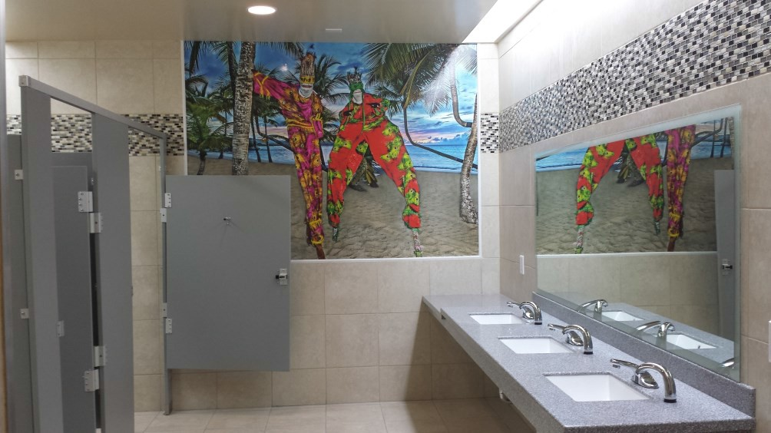HERA Terminal Baggage Claim Restrooms Get Facelift

VIPA Completes

Brand new restrooms in the baggage claim area of the Henry E. Rohlsen Airport Terminal on St. Croix were opened to the public in April 2015. VIPA funded the $154,000 renovations which included a complete overhaul and expansion of the female restrooms (tan) and male restrooms (gray). Colorful artwork by local artist, Lee Lashley of Visual Art Creations, is displayed as a mural on the walls of both restrooms, creating a bright and tropical aura.

VIPA hired FR Maintenance & Construction Services, a local contracting company on St. Croix, to perform the work. VIPA Executive Director Carlton Dowe said that the Port Authority plans to eventually renovate all of the restrooms in the terminal.

Final Phase of HERA Apron Improvements Underway

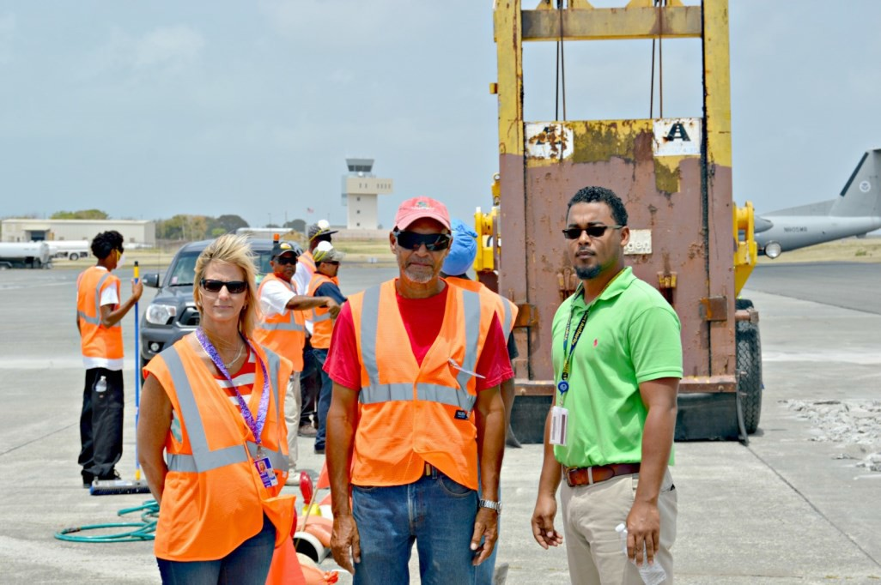The second phase of repairs to the Henry E. Rohlsen Airport Terminal’s apron began in April. Project contractor, Betteroads Asphalt Corporation, LLC. will continue the rehabilitation of the HERA Terminal’s commuter and jet parking apron to eliminate cracks, trip hazards and stabilize the concrete pavement.

The first phase of the HERA Terminal Rehabilitation Project cost about $4.2 million and was completed in December 2014. VIPA is committed to completing these repairs in a timely manner to ensure that the airport is safe for both its users and the travelling public. The project should be completed by September 2015.

VIPA Senior Engineer Damian Cartwright (far right) with Betteroads Asphalt Corporation contractors.

The second phase of this project is 90 percent funded via a $4.9 million Airport Improvement Program (AIP) grant received by the Port Authority from the US Department of Transportation last year. A total of $3.9 million from the grant is to be used for airport development on St. Croix. The Port Authority will fund the remaining 10 percent of the apron rehabilitation project from its Fiscal Year 2015 budget.

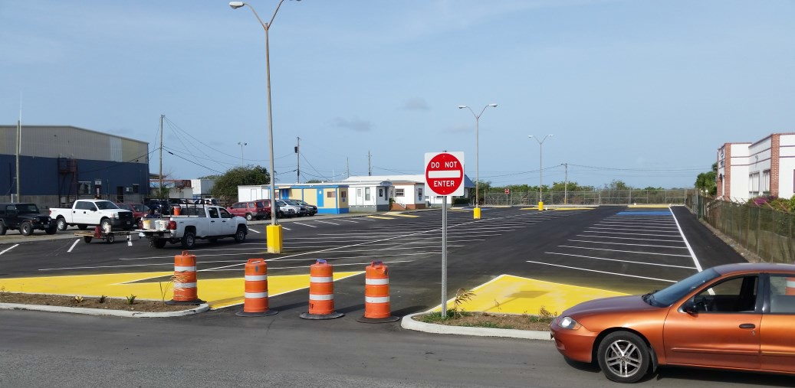Containerport Public Parking Lot Repaved

Parking lot repairs at the Wilfred “Bomba’ Allick Port and Transshipment Center (the Containerport) began in February 2015 and were completed in June 2015 to include resurfacing, proper drainage, a new fence and gates. The lot at St. Croix’s main cargo port is now safe for users of the island’s main cargo facility. The project cost $400,000 and was funded by the Port Authority’s capital improvement budget.

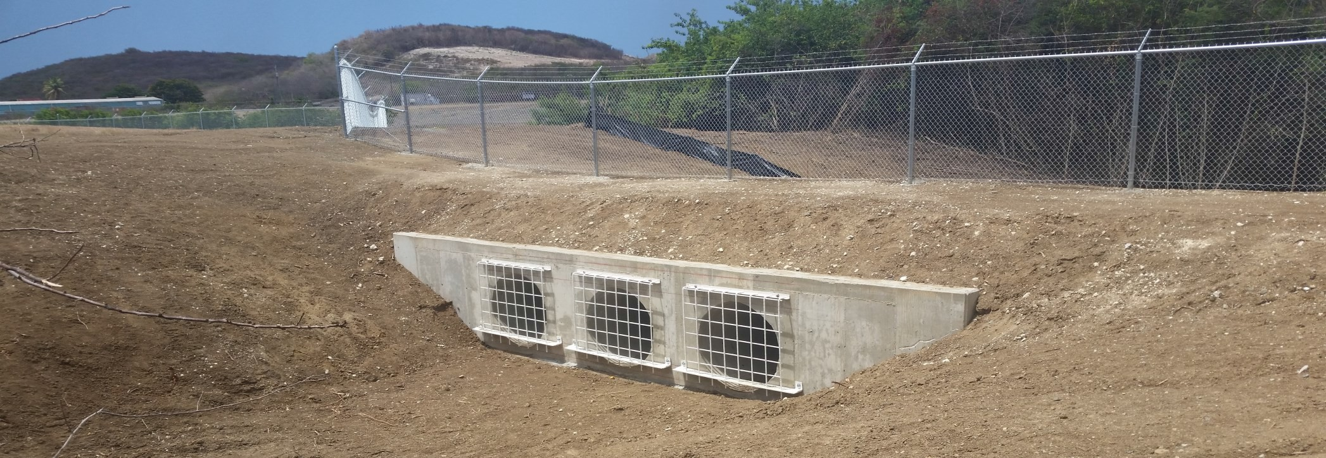Fairplains Gut Project at HERA Completed

VIPA received a grant from the FAA to install 2,200 linear feet of security fencing surrounding Fairplains Gut at the Henry E. Rohlsen Airport - a drainage channel located adjacent to the airfield. During times of heavy rains, the channel was a serious safety concern for airport security officials.

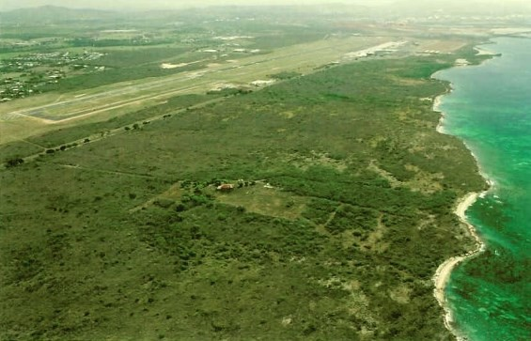VIPA Seeking Developer for Estate Betty’s Hope, St. Croix

On May 27, 2015, VIPA’s Governing Board approved the issuance of a Request for Expressions of Interest (REOI) to develop about 400 acres of land along the south shore area of the Henry E. Rohlsen Airport on St. Croix. The package was released to the public on June 15, and is available online at www.vi por t .com.

VIPA hopes to attract a developer in an effort to generate income from the unused property, as well as introduce a new business to St. Croix and stimulate the island’s economy. The Port Authority is open to all feasible ideas for development of this property.

VIPA Exploring Feasibility of New Cruise Pier in Crown Bay

The Virgin Islands Port Authority Board approved the issuance of a Request for Proposals for a feasibility study on constructing additional cruise ship berths in Crown Bay. This RFP was publicized on June 9, seeking proposals from firms interested in preparing a feasibility study to determine if a berth can be constructed in or adjacent to Crown Bay to accommodate the latest generation of cruise ships coming to the US Virgin Islands. This study should provide a preliminary conceptual development plan, environmental review, indicate potential costs and opportunities and constraints relating to the construction of a new cruise ship pier. Proposals will be opened on July 6, 2015.

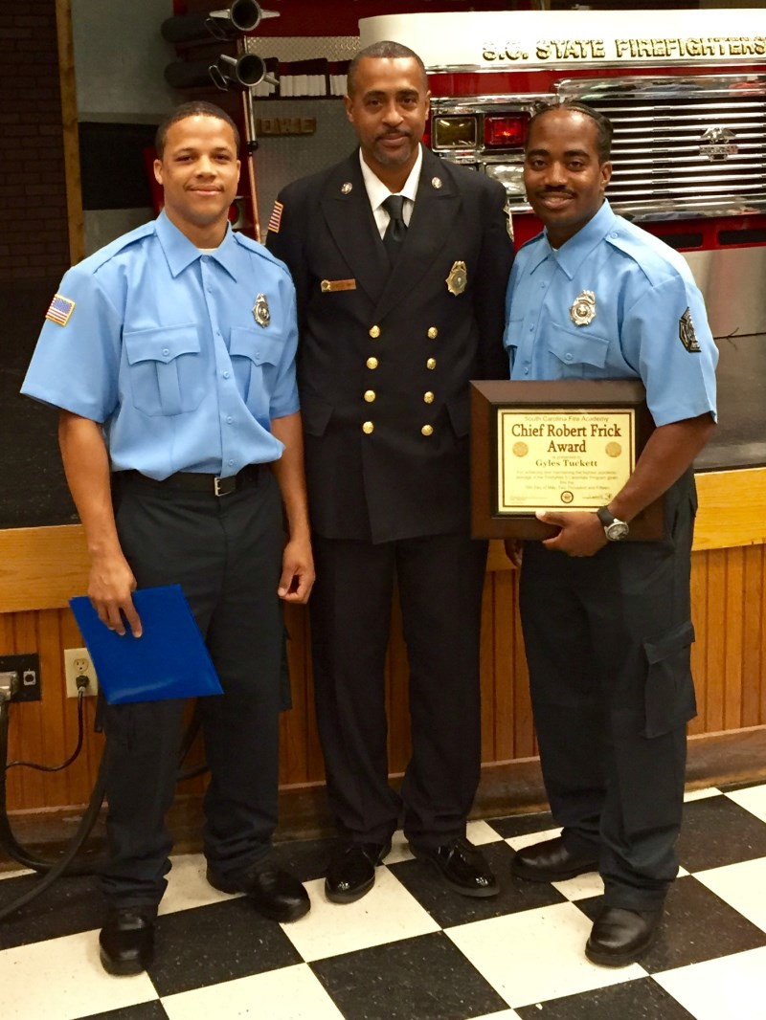LaMotta and Tuckett Join King Airport Fire Fighters

VIPA’s Cyril E. King Airport Fire Chief Derek Smith announced the graduation of two fire fighters from the South Carolina Fire Academy (SCFA). Kyle LaMotta and Gyles Tuckett gr aduated fr om SCFA on May 15. They attended SCFA for eight weeks of intense training. This training included all related subjects for Fire Fighter 1, Fire Fighter 2, and physical fitness agility training.

Tuckett was awarded the Chief Robert Frick A ward for the highest grade point average of all the fire fighters in his class attending the academy. Only 16 of the 23 applicants passed the class, said Smith.

Tuckett and LaMotta will be moving on to the specialized training in Aircraft Rescue Fire Fighting (ARFF) on May 18-22 and will be returning to St. Thomas for duty assignments at the King Airport on St. Thomas after receiving their ARFF certification.

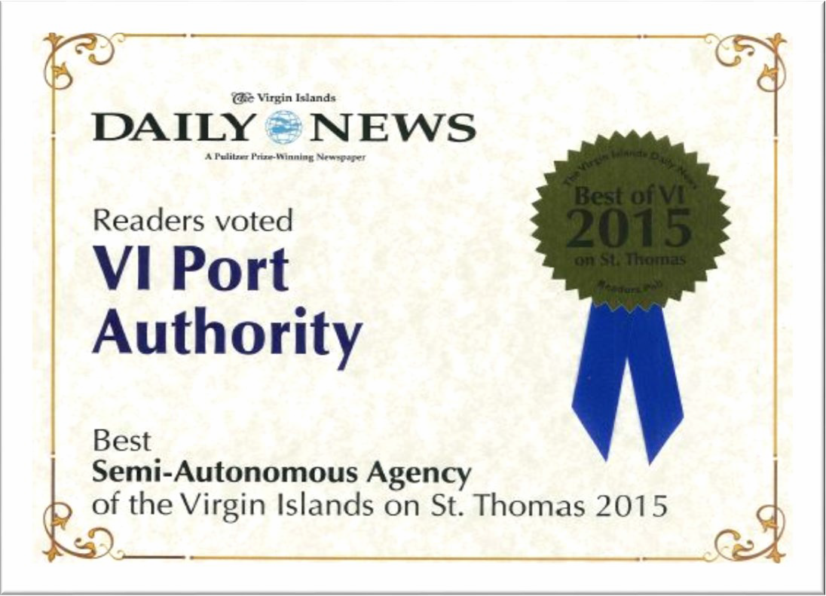VIPA Firefighter Kyle LaMotta, CEKA Fire Chief Derek Smith and Firefighter Gyles Tuckett who graduated from SFCA with the highest grade point average in his class.

VIPA Thanks Voters

VIPA Executive Director Carlton Dowe thanked the readers of the VI Daily News who voted the Port Authority as the best semi-autonomous agency on St. Thomas. Dowe said, “This perhaps is one of our greatest measuring tools of success. To have our community vote for us as the best semi-autonomous agency is a clear indication that they are observing the work that we are doing and they are appreciative of our efforts and progress thus far. We are humbled by their vote of confidence and will continue to work to meet the needs of the traveling public.”

VIPA’s New Chief Financial Officer and Director of Human Resources

Donna Frett-Gregory joined the Vir gin Islands Por t Author ity as its Chief Financial Officer on March 15, 2015. In her capacity as CFO, Gregory has oversight of the Authority's administration and finance, accounting, IT and purchasing departments. She is charged with creating innovative practices to improve the Authority's financial and credit standing; performing regular reviews of the Port Authority's aviation and marine tariffs; oversight of the annual financial audit; managing the Authority's assets; ensuring the agency obtains the most adequate and affordable insurance liability coverage; and developing all purchasing, financial and informational technology procedures for the agency.

Gregory has 28 years of public financial management experience. She holds a Master of

Business Administration from Western Governors University, a Master of Arts in Public
Donna Frett-Gregory

Administration from the University of the Virgin Islands, and a Bachelor of Science in Business Administration from Morgan State University. Ms. Gregory successfully completed the State Leaders in Government Program at the Harvard Kennedy School of Government in 2011.

Dayna M. Clendinen joined VIPA on Apr il 13, 2015 as the Dir ector of Human Resour ces. She is responsible for personnel recruitment, orientation, training and all other aspects of human resources activities at the Port Authority. Clendinen represents VIPA in all negotiations and communications with employee unions, health insurance boards and local and federal labor agencies.

Clendinen holds a Bachelor of Arts degree in Communications and a Master of Science degree in Organizational Change and Leadership Management. She has over 10 years of public and private executive experience in operations, human resources, strategic planning and administration. She served as the Assistant Commissioner and the Deputy Commissioner of

Administration for the VI Department of Public Works. She has also served as the
Dayna M. Clendinen

Administrator for Human Resources with the North Carolina Foundation and Executive Assistant to the Vice President for Organizational and People Development and the Director of Global Resourcing and Financial Analysis at GlaxoSmithKline.

CLARISSA C. DANIEL
Bookkeeper Accounting/Marine, St. Croix
LIONEL A. SPRAUVE
Dock Master Marine, St. John

VIPA Portfolio Spring/Summer 2015 Page 7

VIPA Promotes Good Health and Physical Fitness

The VI Port Authority is on a health kick! VIPA has chosen to give back to its community by sponsoring health fairs, free glucose, hypertension and HIV testing, nutrition classes and exercise programs at the Crown Bay Center on St. Thomas and the Ann E. Abramson Pier on St. Croix. The health fairs and Zumba® Fitness Challenges on St. Thomas wrapped up in May, and concluded in June on St. Croix. Both programs challenged participants to attend weekly Zumba classes and VIPA awarded a trip and prizes to those that lost the most weight.

VIPA recently kicked off its new S.W.E.A.T program that will be
hosted at the Crown Bay Center. The program runs from June 9
through September 30 and will feature three classes per week: Tuesdays Zumba®, Wednesdays Pilates and Toning, and on Thursdays Socarobics. There will also be nutrition classes and monthly weigh-ins, plus assistance for VI Government employees to complete their annual health assessment screenings. The program costs $50 or participants may pay $5 per class. For more information visit www.vi por t .com, call (340) 774- 2132, or e-mail Cr ownBay@vi por t .com.

Lindbergh Bay Clean Up

VIPA’s Executive Director Carlton Dowe, CFO Donna Frett-Gregory, Maintenance Manager Felicia Blake and Maintenance employees Lewis Nichols and Daron “Chucky” Angol joined Alpha Kapa Alpha Sorority volunteers in a recent clean up of the Lindbergh Bay Beach and Park on St. Thomas.

VIPA Executive Director Carlton Dowe and staff met with St. John residents to discuss Port policies, current activities and planned developments for St. John’s seaports.

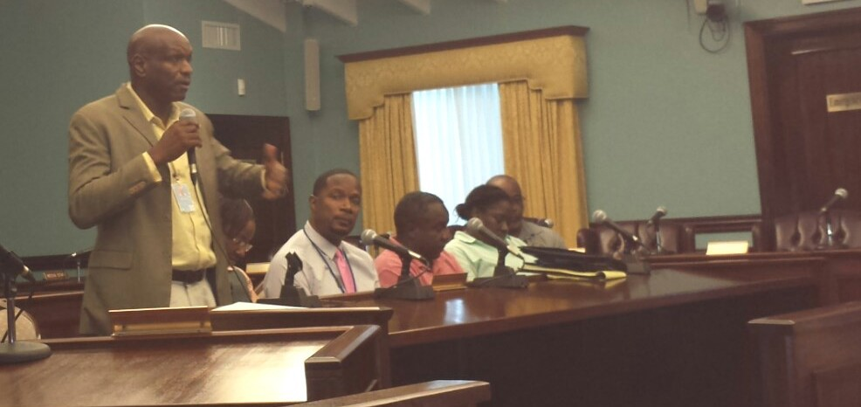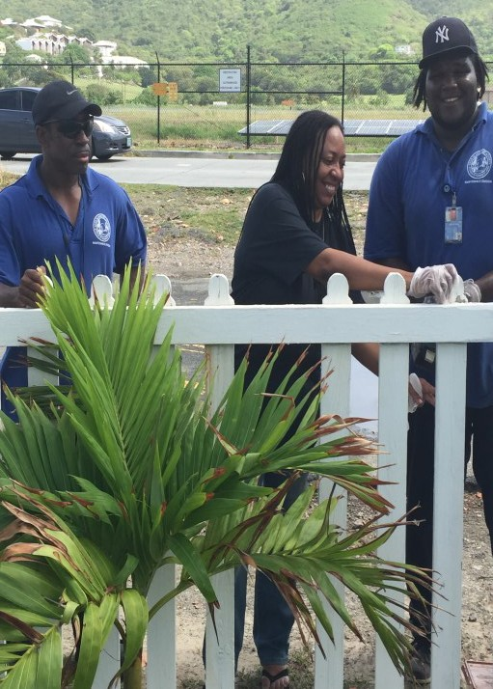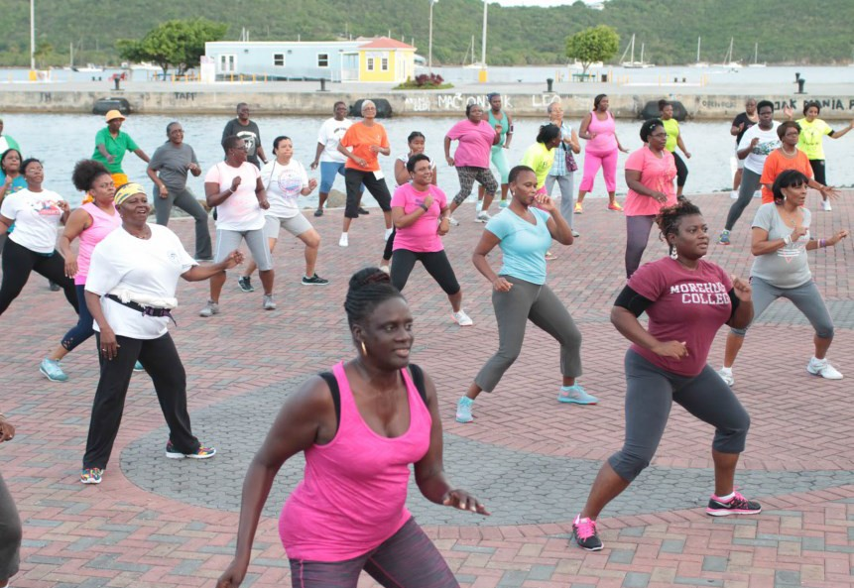

VI Port Authority Law Enforcement Officers helped the VI Police Department to ensure the safety of revelers at the 2015 Carnival J'ouvert held on St. Thomas in April.

