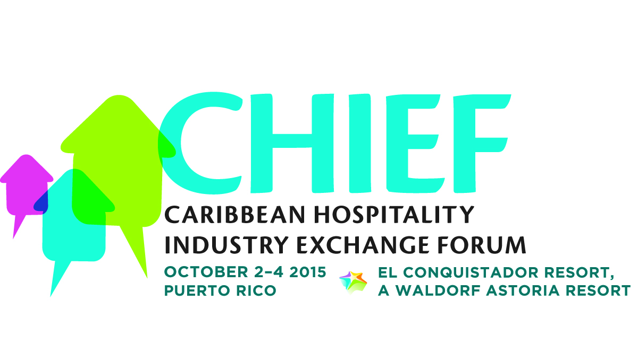

MEDIA CONTACTS:
KTCpr
Theresa M. Oakes / T.Oakes@KTCpr.com
Richard Kahn / R.Kahn@KTCpr.com
Telephone: 516-594-4100
#1097

CHTA’S 'CHIEF' HOSPITALITY FORUM FEATURES OPERATIONS, SALES & MARKETING, SUSTAINABILITY STRATEGIES
Best Practices, Hands-On Learning Designed To Help Hotels 'Make & Save More Money'
THE CARIBBEAN (May 21, 2015) – The Caribbean Hotel & Tourism Association (CHTA) has designed a comprehensive program for its new Caribbean Hospitality Industry Exchange Forum (CHIEF) offering engaging sessions focused on helping its membership generate revenue, reduce costs and become more efficient. CHIEF will be held Oct. 2-4, 2015 at El Conquistador Resort, A Waldorf Astoria Resort in Puerto Rico.
CHIEF incorporates a variety of educational tracks lead by experts from a variety of travel, tourism and hospitality industry segments featuring panels with one-on-one discussions in Sales & Marketing, Operations, and Sustainability.
"Members attending CHIEF will have the opportunity to discuss real situations and solutions for challenges faced in the day-to-day business of operating and marketing a property in the Caribbean," said Emil Lee, president of CHTA. "By participating in CHIEF, CHTA members will learn how they can make more money and save more money as they network with each other and industry experts," Lee added.
General sessions at CHIEF include:
- Peering Into the Future: Turning Knowledge Into Dollars - Change is constant with global and regional factors taken into consideration in today’s decision-making. A panel of industry experts paints the tourism picture, providing data which gives added insight into global and regional economic performance, industry and travel trends, and technological changes affecting how we do business.

- Future of Travel Distribution: Are You Tuning Into the Right Channels? - This session will explore changes in channel demand and the impact on hotels and resorts in the region. The session will look at trends in GDS, OTAs, hotel direct, mobile voice and other channels while providing suggestions for implementing a channel-management strategy to grow revenues. The discussion will review the relevancy of travel agents in this changed environment.

- Cuba: Opportunity or Threat? - Will the US-Cuba normalization affect your business? If so, how can you minimize any potential downside impact? What opportunities might Cuba present for your hotel and the region?

In addition to the general sessions, CHIEF offers a variety of educational tracks so all attendees can walk away with practical business tips.
The Sales & Marketing Track will feature breakout sessions about the following topics:
- Ratings and Reviews: Does It Matter What They Say About You? - Perception is reality and an online reputation is available for the world to see. Learn the value of maximizing user-generated reviews. Turn good reviews into exceptional opportunities and negative reviews into teachable moments and loyal customers.

- Public Relations: An Underused Strategy For Priceless Results - Turn PR into gold! Effective public relations strategies can be a low-cost tool to drive awareness and demand, particularly in the Caribbean. With today’s technology there are many channels available to accomplish this. Considering self-promotion or hiring a pro? Hear from public relations pros about how to develop an effective PR plan to drive “word of mouth” for the hotel.

- The Riches Are In The Niches - Niche markets present small and big hotels with tremendous opportunities to grow the business. Explore traditional and new niche markets and understand the best matches for your property. Know which ones are trending in the region and how to access opportunities to increase your share. The discussion will look at demographics and social graphics of each niche. Being better than the competition is a start, but identifying and engaging niche-specific travelers can truly boost hotel revenues.

- Unleash The Potential Power Of Your Customer Data & Make Data Driven Marketing Decisions – Hotel owners, operators and marketing professionals need to be aware of the data that is already available to help increase sales. Learn how to make strategic data-driven decisions using the assets to expand reach, enhance awareness, drive traffic to the chosen channels and dramatically increase ROI.

- Would You Follow Me? Driving Sales Thru Social Media - It is all about creating a successful strategy. Learn how to leverage social media, promote the brand and reach customers when they are ready to buy throughout all social platforms.
The Operations Track will provide insight about these important topics impacting hotel procedures:
- How Smart Is Your Hotel? - Keeping current with technology is as important as the property’s physical infrastructure. Understand the hottest trends in technology (property management systems, guest service, entertainment, doorlocks, energy efficiency) and how these will make the overall operation more efficient which will translate into guest satisfaction.

- Are You Really Planning For Profit? - As the saying goes, “if you fail to plan, you plan to fail.” Operating a hotel without a budget, sales plan, and a sound business plan can spell financial disaster. By having a plan, profit is not limited to what’s left in the cigar box at the end of the year. A sound plan should provide benchmarks for exceeding targeted performance. Hear tips for developing and implementing a business plan to drive hotel success.

- Your Staff Can Make Or Break Your Hotel! Build And Leverage Your Team To Maximize Results - Are the right staff being hired and are the employees working to their fullest potential? The human element is the most important asset of any business. This session delivers helpful advice for hiring, training and retaining employees.

- Are You Delivering The Caribbean Dream? How To Maximize Guest Experience - Nothing beats personal interaction and engaging service. Customers still thrive to achieve the experience of a lifetime when they travel, particularly to the Caribbean. What are the critical touch points and how best to drive guest satisfaction? Hear from a panel of experts on how to provide five-star services and measure the results.

- No More Capes – Do You Need To Be A Superhero To Run A Hotel? - In small and independent hotels, owners, managers and staff must wear many hats. Hear first-hand from industry peers how they’ve managed to juggle multiple responsibilities without dropping the ball, creating wonderfully successful hotels.

The Go-Green: Improve Profitability education track will focus on the following:
- Are You Leaking? - Water and electricity losses go directly to the bottom line. Regional research reveals that hotels are spending up to 30% more in electricity than they should. And water losses drain the bottom line even more. Learn about proven no-cost, low-cost and manageable investment costs which can stop the leakage. Hear from hoteliers who have successfully implemented energy management plans showing results based on tracking data and benchmarks.

- Bright Ideas, Big Savings - Trying to figure out where to begin? Lighting, air conditioning and refrigeration all require initial investments to save money. Examine how to best weigh the options. What type of equipment, fixtures and materials can best save money? Wondering how to pay for these investments? Learn from experts about the options, and hear more about cost-effective purchasing and financing arrangements to maximize ROI

- Turning Dirt Into Dollars - This ‘ground table’ session takes participants on a walk around the grounds of El Conquistador. Suggestions will be given about how landscaping and on-property gardens can save money, while creating positive guest impressions as well as an educational and memorable guest experience.

- Is There An ROI On Being Environmentally Certified? - Confused about Green Key, LEED and Green Globe? What’s the hype versus the reality? What’s the bottom line impact on being certified? Does it go beyond goodwill? Does it translate into better efficiencies and new business? Is the cost worth the benefit? Hear more about the various certification options in the market, and whether certification is right fit for the property.

- Renovate, Retrofit, Refurbish: Expense or Revenue Generator? - When opting to hold-off on any major refurbishments or upgrades, understand how it affects room rates and overall guest satisfaction. During the session learn what level of investment is needed to see a return and how long can major cap-ex expenses can be held off. In today’s competitive environment, product can’t become stale. Hear about trends in refurbishment and how to manage for the highest possible ROI.

In addition to the sessions and educational discussions, CHIEF will feature an interactive tradeshow format that has been designed so exhibiting CHTA allied members can interact with CHIEF participants through live demonstrations of their products and services. Exhibitors will offer exclusive discounts on services and products to CHIEF attendees.
CHIEF attendees also will have the opportunity to network with industry colleagues at various social events, cocktail receptions and fun trade show activities. Exclusive CHIEF nature tours of Puerto Rico, shopping expeditions, spa packages and other activities will be offered to participants and their families.
As part of the CHIEF program, an awards luncheon will be held where CHTA honors the "Stars of the Caribbean Hotel Industry" including Caribbean Hotelier of the Year, Association Executive of the Year, Supervisor of the Year, Employee of the Year, and Allied Member of the Year as well as the winners of the new CHIEF Awards.
Registration and Hotel Accommodations
CHTA is offering an Early Bird registration for delegates who confirm by Aug. 1, 2015. Registration includes access to the event, all educational sessions, conference materials, two lunches, coffee breaks and two receptions. Registration fees are as follows and are quoted per person:
- CHTA hotel members: $395 ($445 after Aug. 1)
- CHTA small hotel members (75 rooms or less): $295 ($345 after Aug. 1)
- CHTA hotel group (after two delegates): $295 ($345 after Aug. 1)
- CHTA allied member: $495 ($515 after Aug. 1)
- Tabletop displays (includes one delegate registration: $995 ($1,045 after Aug. 1)
Non-member hotels can register as well for $645 ($695 after Aug. 1) with the fee including one year of membership in CHTA. Allied companies that are not members of CHTA will also be given one year of membership as part of their CHIEF registration which is $1,095 ($1,145 after Aug. 1).
CHTA has secured a nightly rate of US$125 per room exclusive of taxes at El Conquistador Resort. A number of airlines are also providing special discounts to attendees for the event dates.
Registration and complete event details are available via: www.chtachief.com. To register, email events@caribbeanhotelandtourism.com or call 786-476-8623.
Sponsorship
CHIEF is staged with the assistance of patron sponsors Interval International and MasterCard; platinum sponsor Travelzoo and gold sponsor Sojern.
CHTA is accepting sponsors for specific programs at CHIEF. Companies interested in learning more about sponsorship opportunities should contact Matt Cooper, chief marketing officer, matt@caribbeanhotelandtourism.com or (305) 443-3040.
Caribbean Hotel & Tourism Association
The Caribbean Hotel & Tourism Association (CHTA) is a federation of 32 National Hotel Associations, with more than 600 member hotels and over 300 allied members. CHTA is the largest representative of the private sector in the Caribbean hotel and tourism industry. We are the voice of the Caribbean hospitality industry for the development of the region in the highly competitive and sophisticated environment of international tourism. Today, tourism is widely recognized as a pivotal industry in the economy of the region – and CHTA functions as the common denominator for this industry in a region of diverse nationalities, languages and styles, identifying mutual problems and marshaling the resources of the active and allied members to devise solutions. CHTA represents all facets of the hospitality industry with more than 600 member hotels and over 300 allied members.
CHTA, including the events staged by the association, is supported by Strategic Partners MasterCard, Cable & Wireless, HVS, Interval International, OBM International, Tambourine and TravelZoo.
For more information, visit http://www.caribbeanhotelandtourism.com. Follow CHTA on Facebook Facebook.com/CaribbeanHotelandTourismAssociation and Twitter Twitter.com/CHTAFeeds.
###

