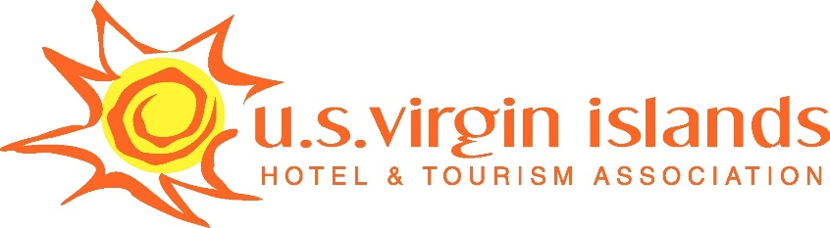

2018 SUMMER EMPLOYMENT PROGRAM

EMPLOYER COMMITMENT FORM

Please complete this form in its entirety and return via reply e-mail by Friday, May 18, 2018.

______________________________________ will participate in the Hotel & Tourism
(Name of Business) Associations’ 2018 Summer Employment Program.

Contact/Title: _________________________________________________________

Tel/Fax/Email: ________________________________________________________

Authorized Signature: __________________________________________________

Placements
# of Students Department
_______________ ________________________________________________

_______________ ________________________________________________

_______________ ________________________________________________

_______________ ________________________________________________

_______________ ________________________________________________

_______________ ________________________________________________

“Thank you for your support!”

