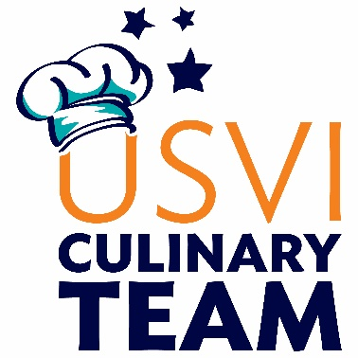

For 13 years, the USVI Hotel & Tourism Association has sponsored the U.S. Virgin Islands Culinary Team, a group of professionally trained chefs who represent our islands at the annual *Taste of the Caribbean* Competition [www.chtataste.com](http://www.chtataste.com). The team, comprised of 3 chefs, a pastry artist, bartender, alternates, students, and team captain, match their epicurean skills against over 15 teams from the Caribbean region in a quest for culinary superiority.

In the 2017 competition, the team brought home the SILVER and this year we are going for the GOLD! In addition to winning silver overall, team members were awarded several medals throughout the competition, including Chef of the Year, Pastry Chef of the Year, Bartender of the Year, and Seafood and Beef Competition medals. This year’s competition will be held in **Miami, Florida June 26-30, 2020.**

In an effort to encourage budding chefs in the territory, the team also includes student cooks from the Charlotte Amalie High School, St. Croix Central High School and/or the St. Croix Educational & Technical School, who shadow the team at both practices and the competition. These students also have the opportunity to compete in their own competition at the Taste of the Caribbean.

The team could not compete without the support of generous benefactors. Sponsors assist the team with travel and accommodation expenses, team jackets, fundraising events, student apprentice training, and competition supplies. The level of sponsorship is outlined on page two with benefits.

We hope that you will consider being a part of the team by remaining a valued sponsor. If we can answer any questions don’t hesitate to contact us at 774-6835 or email Lisa Hamilton at [lisa@virgin-islands-hotels.com](mailto:lisa@virgin-islands-hotels.com). We will be contacting your office to confirm your support.

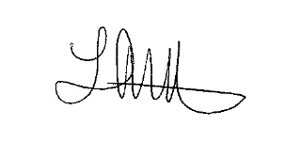Sincerely,



Lisa Hamilton Rodney Renner

USVI HTA President USVI HTA Chairman of the Board